Community Foundation News


No. 64 March 30, 2007

Scholarships Awarded in 2006

Rae-Anne McCourt of Summerside was awarded the Summerside Natick Hockey
Scholarship to attend St Thomas University
Ryan Keefe of Summerside received the Orin Carver Scholarship to attend UPEI
Jessica Hutchinson of Bonshaw received the Joan Auld Scholarship to attend the
Kootenay School of the Arts
Christopher Dahn of Cornwall received a Joan Auld Scholarship to attend the Nova
Scotia College of Art and Design
Andrea Gallant of Alberton received the Lowell Phillips Scholarship to attend UPEI
Carolyn Doucette of Kensington received the Lorne and Ruby Bonnell Scholarship
to attend Dalhousie University

Orin Carver Scholarship

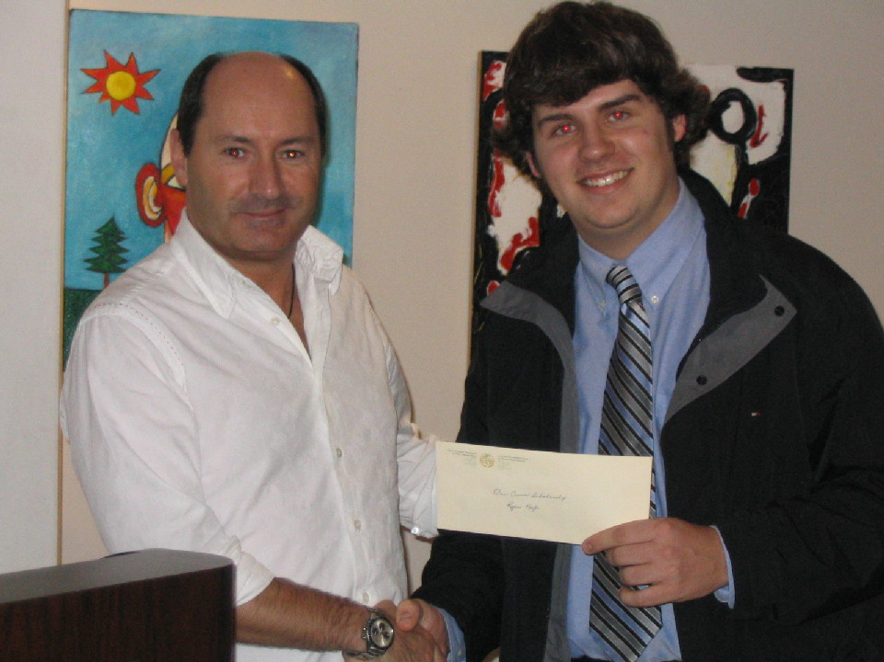

The photo above shows David Carver, son of the late Orin Carver, presenting the Orin Carver Scholarship to Ryan Keefe of Summerside.
APPLICATIONS- 2007

Closing date May 31, 2007

Applications are now being received for the above mentioned scholarships. For information about scholarships and printable application forms, check our website:
www.cfpei.ca

Scholarship Applications

Why a scholarship at CFPEI?

We are sometimes asked why scholarships are set up at the community foundation when most Islanders go to either UPEI or Holland College. The reason is simple. CFPEI scholarships:
- can follow a student off PEI to a college or university elsewhere in Canada or even out of country,
- may be available for specialties not available on PEI,
- may follow a student who moves between institutions. We know, for instance, that students at Holland College or UPEI take further studies at the other institution.
- can be designed for studies not found in traditional institutions.

_______________________________________
The Community Foundation News is an informal newsletter, in electronic form only, edited and published by, and at the whim of, Don Glendenning. Think of it as a letter from a friend. Forward this to others who may be interested. For further information, check our website, www.cfpei.ca or Email me at: don@glendenning.net

